**Innovation/Approach**

1. Ciarra Alemeria et al., Heterogeneity of mesenchymal stem cell-derived extracellular vesicles is highly impacted by the tissue/cell source and culture conditions [1].

Cell & Bioscience 2022 - Doi: 10.1186/s13578-022-00786-7

1. Describe the process parameters that crucially affect the MSC therapeutic properties and biological functions: cell source, medium composition.
2. The authors discuss the bioreactor culture which produce MSC-derived EV’s with less inflammatory factors and suppressed T cell and macrophage infiltration. We want to control the effects of the engineered MSC and notbeing pro-tumorigenic.
3. Additionally, bioreactors allow to scale up production, enable continuous culture and monitoring of critical process parameters, such as O2 and pH.
4. Description of common isolation protocols and more modern separation techniques for MSC-Evs.
5. The paper describes EV storage approaches.

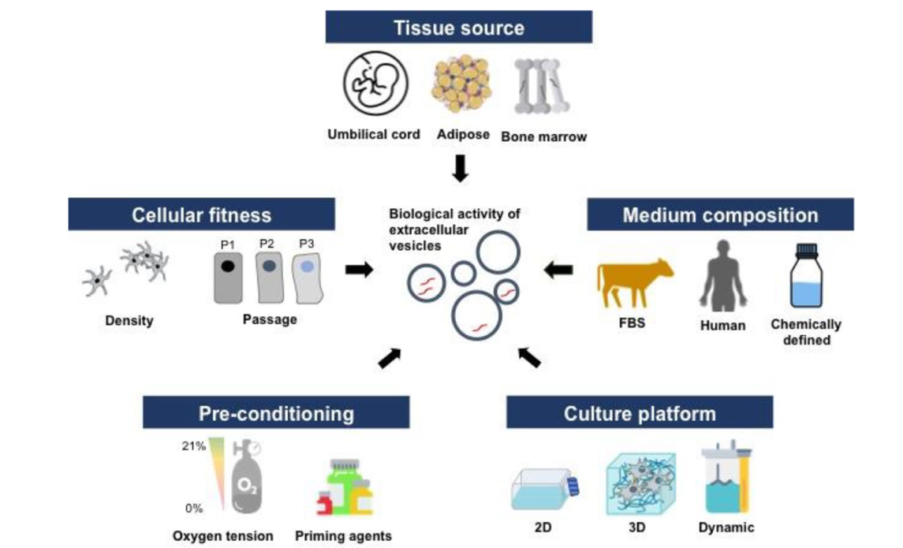

Key considerations for MSC-derived EV production

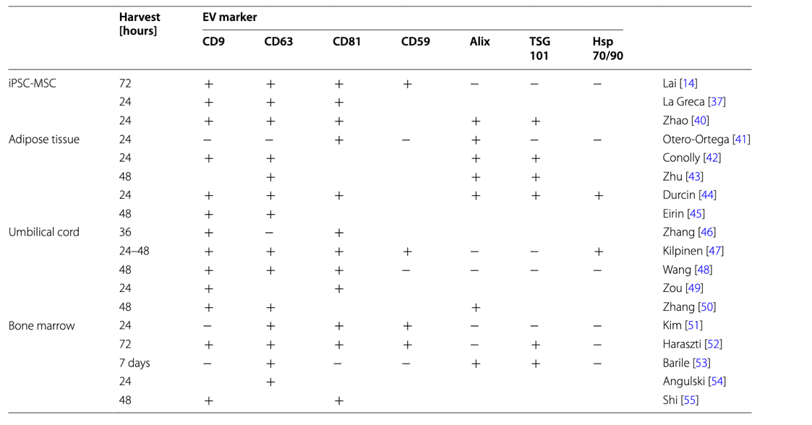

EV Specific surface markers

1. Dupuis et al., Methods to produce induced pluripotent stem cell-derived mesenchymal stem cells: Mesenchymal stem cells from induced pluripotent stem cells- 2021 Aug 26. doi: [10.4252/wjsc.v13.i8.1094](https://doi.org/10.4252%2Fwjsc.v13.i8.1094) [2]

The source of the iPSC-MSCs and the method used for exosome preparation can influence their immunogenicity. Autologous sources (derived from the same individual receiving the exosomes) would theoretically pose the least risk of immune reaction, but allogeneic sources (from a donor) are also considered due to MSCs' naturally low immunogenicity.

1. Describe the main current protocols used to differentiate human iPSCs into MSCs: MSC Switch, Embryoid Body Formation, Specific Differentiation, Pathway Inhibitor, and Platelet Lysat.
2. The MSC Switch method emerges as the predominant choice, with six method variants cited over 100 times (refer to Table 1). It appears to be the least complex of the protocols, at the expense of, perhaps, increased variability of the obtained iMSCs

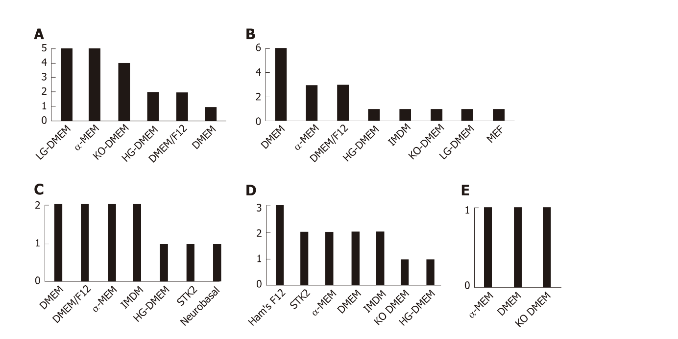

Relative frequencies of commercial media in 32 studies

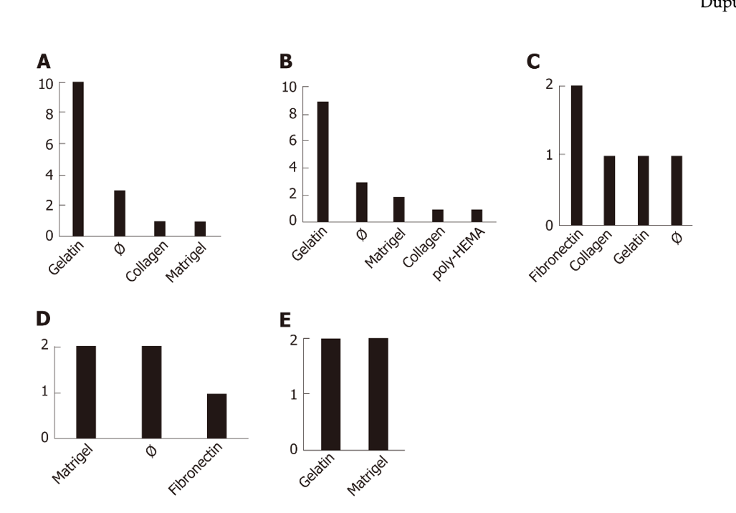

Coating used to produce induce pluripotent stem cell-derive mesenchymal stem cells.

1. Zhijie Weng et al. Therapeutic roles of mesenchymal stem cell-derive extracellular vesicles in cancer. Journal of Hematology & Oncology 2021 - Doi: 10.1186/s13045-021-01141-y [3]
2. This review explores the diverse roles of MSDC-derived EVs, focusing particularly on their applications as anti-tumor agents. The characterization of MSCs often involves the assessment of specific protein markers, including CD9, CD63, CD81, CD59, as well as cytosolic proteins such as ALIX, TSG101, and Hsp70/90, through techniques like Western Blot or ELISA.
3. The review discusses the impacts of MSC-derived EVs on cancer cells, we may want to investigate the possibility to transect different MSC-derive types for different cancer types or use only iPSC-MSCs.
4. The review examines different strategies for cargo engineering, comparing pre-loading and post-loading techniques.

* CSF-1R inhibitors can be conjugated to the exosome surface using linker molecules that covalently attach to functional groups on the exosome membrane or the Lamp2b protein.
* For targeting TAMs, peptides that specifically to CD68 or CD163 could be identified or engineered.
* For cancer cells, short peptides or scFv (single-chain variable fragments) that recognize EpCam, HER2, or CA125 could be fused to Lamp2b. The paper references a study in which BMSC-derived exosomes were tagged with the 5TR1 aptamer, which has a close affinity with MUC1 protein
* Adding a glycosylation motif, such as GNSTM, to the fusions can indeed improve the stability and solubility of protein fusions. Glycosylation can enhance resistance to proteases and improve the overall pharmacokinetic properties of the exosomes.

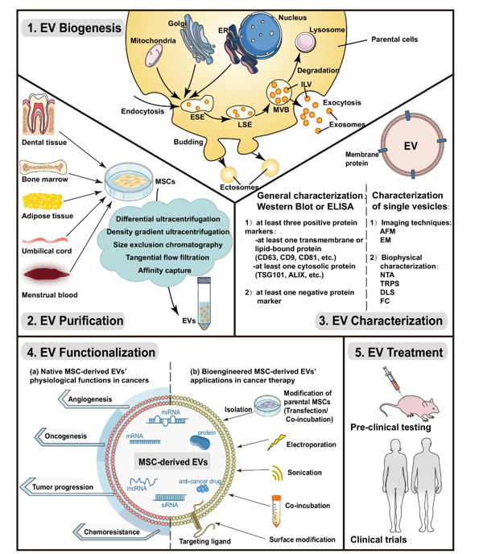

Critical stages involved in utilizing MSD-derived EVs for therapeutic purpose

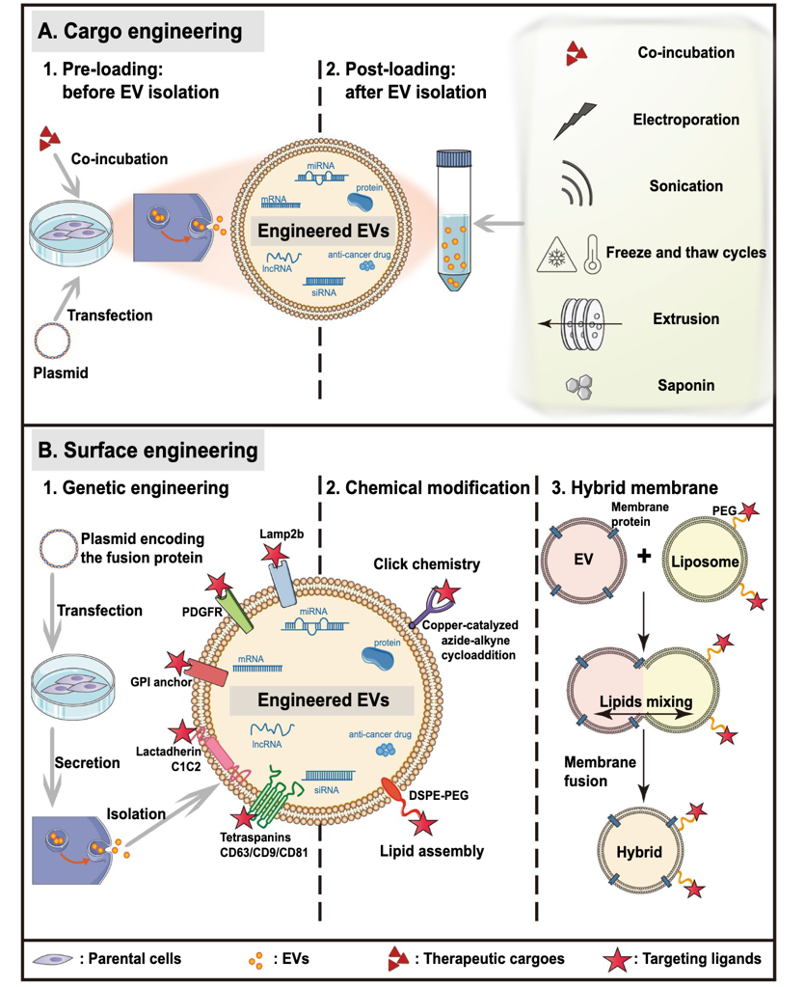

Current technologies for EV bioengineering

1. Jiaci Chen et al. Review on Strategies and Technologies for Exosome Isolation and Purification – 2022 Frontiers in Bioengineering and Biotechnology [4]
2. Review common exosomal separation techniques but also emerging technologies with better performance, simple and affordable such as microfluidic chip
3. Common exosome isolation technologies including ultracentrifugation (“gold standard”)

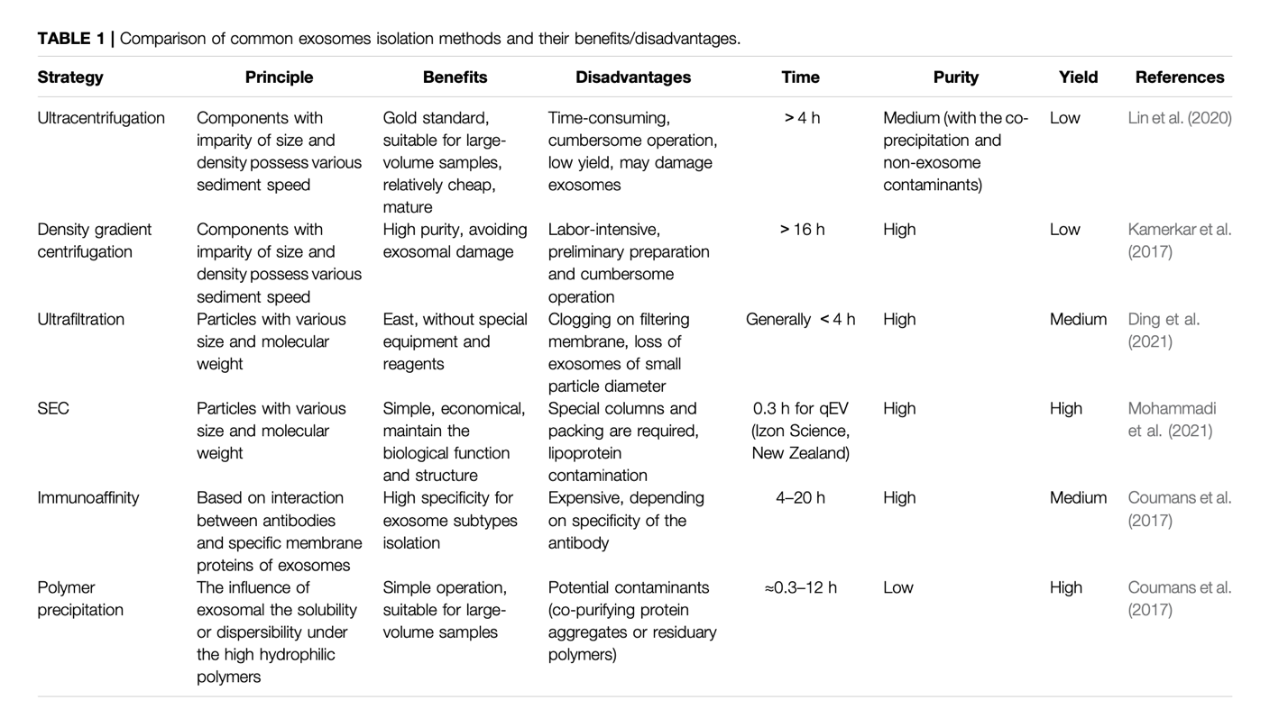

1. Description of microfluidic system which can isolate exosomes with high purity, minimizing contamination form other extracellular vesicles or protein aggregates. The process is more efficient and requires less time than ultracentrifugation techniques, it can be scaled up and the same system can be used for exosome modifications.

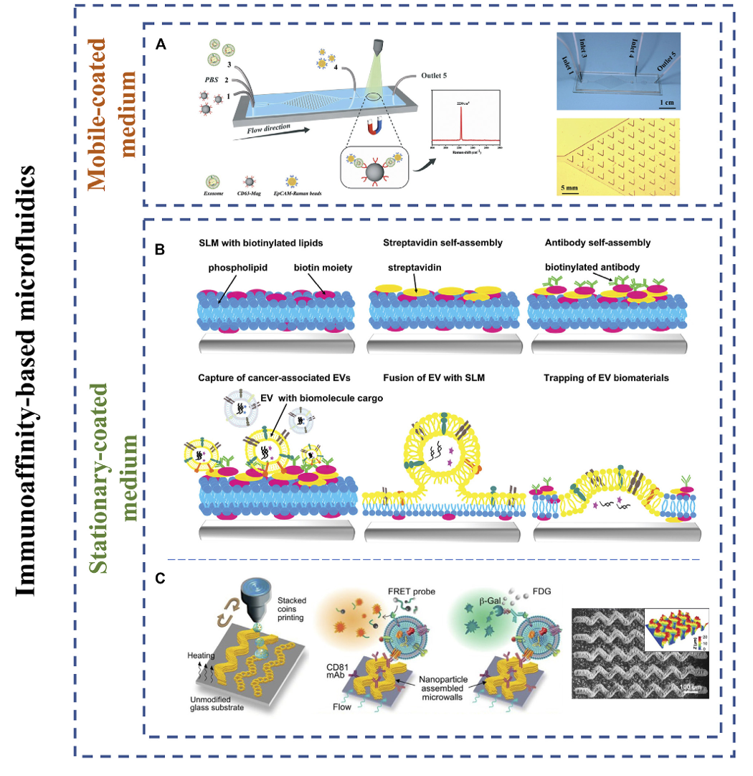

1. Cristiana Ulpiano et al., Bioengineered Mesenchymal-Stromal-Cell-Derived Extracellular Vesicles as an Improved Drug Delivery System: Methods and Applications – Biomedicines 2023 – Doi: 10.3390/biomedicines11041231 [5]
2. Good overall review of bioengineered MSC-derived EVs

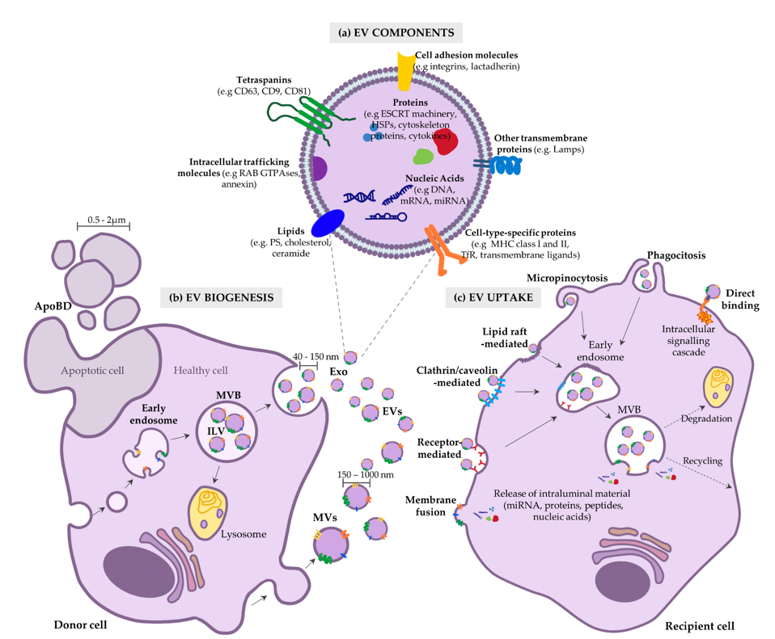

Basic of EV compound delivery

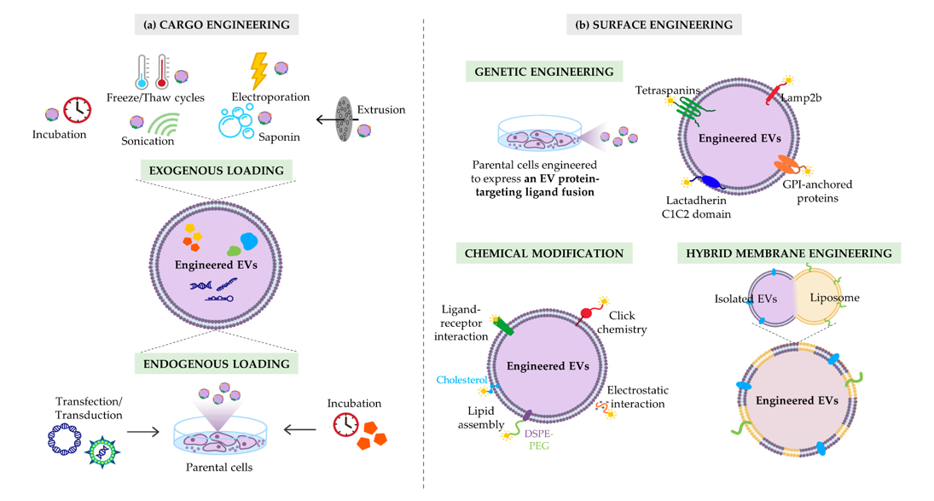

Strategies to maximize the therapeutic efficacy of EVs

6) Luisa Pascucci et al, Paclitaxel is incorporated by mesenchymal stromal cells and released in exosomes that inhibit in vitro tumor growth: A new approach for drug delivery – Journal of Controlled Release – 2014 – Doi: 10.1016/j.jconrel.2014.07.042 [6]

1. This research describes the whole protocol for loading MSCs with the drug Paclitaxel (PTX) and isolated them using ultracentrifugation.
2. They used transmission (TEM) and scanning electron microscopy (SEM) to analyze the MSC’s membrane microvesicles (MVs) to understand their roles in the release mechanism of PTX.
3. They used the Fourier transformed infrared (FTIR) micro spectroscopy to detect PTX.
4. They used the murine SR4987 line as MSC model. When they loaded SR4987 with PTX (SR4987PTX), they found that they release of MVs but these MVs look like untreated SR4987. However, SR4987PTX-derived-MVs (SR4987PTX-MVs) were very effective at stopping the growth of human pancreatic cell line CFPAC-1.

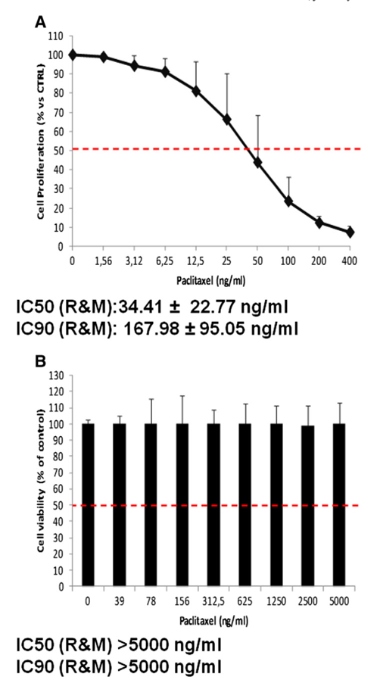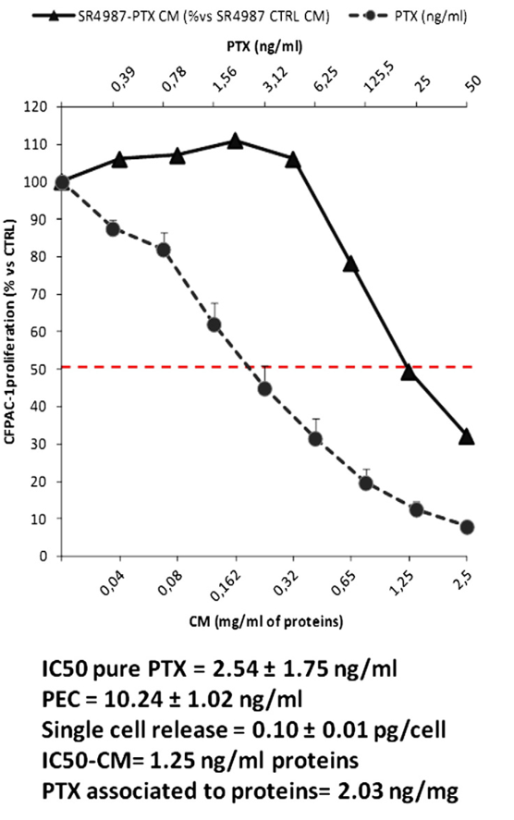

Sensitivity of SR4987 to PTX. Addition of a dose-dependent SR4987-CM was able to reduce the proliferation of CFPAC-1

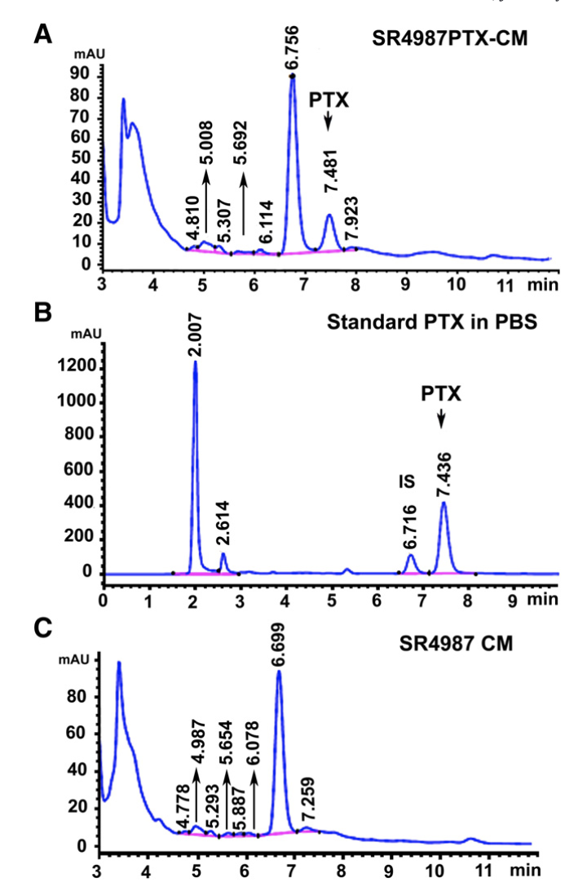

Presence of PTX in SR4987PTX-CM is confirmed by HPLC analysis: peak on elution profile (A) is like profile (B) which is related to standard PTX at 1.000 ng/ml.

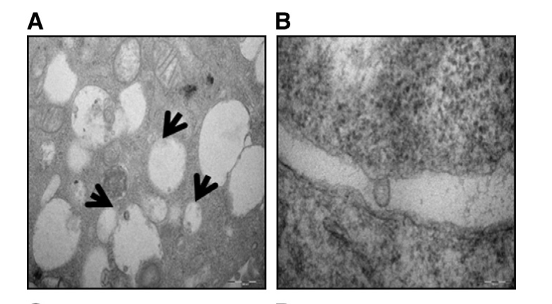

TEAM analysis of SR4987PTX shows an increased number of “vacuole-like” structures (MVs)

Anti-tumor activity of MVs from SR4987PTX.

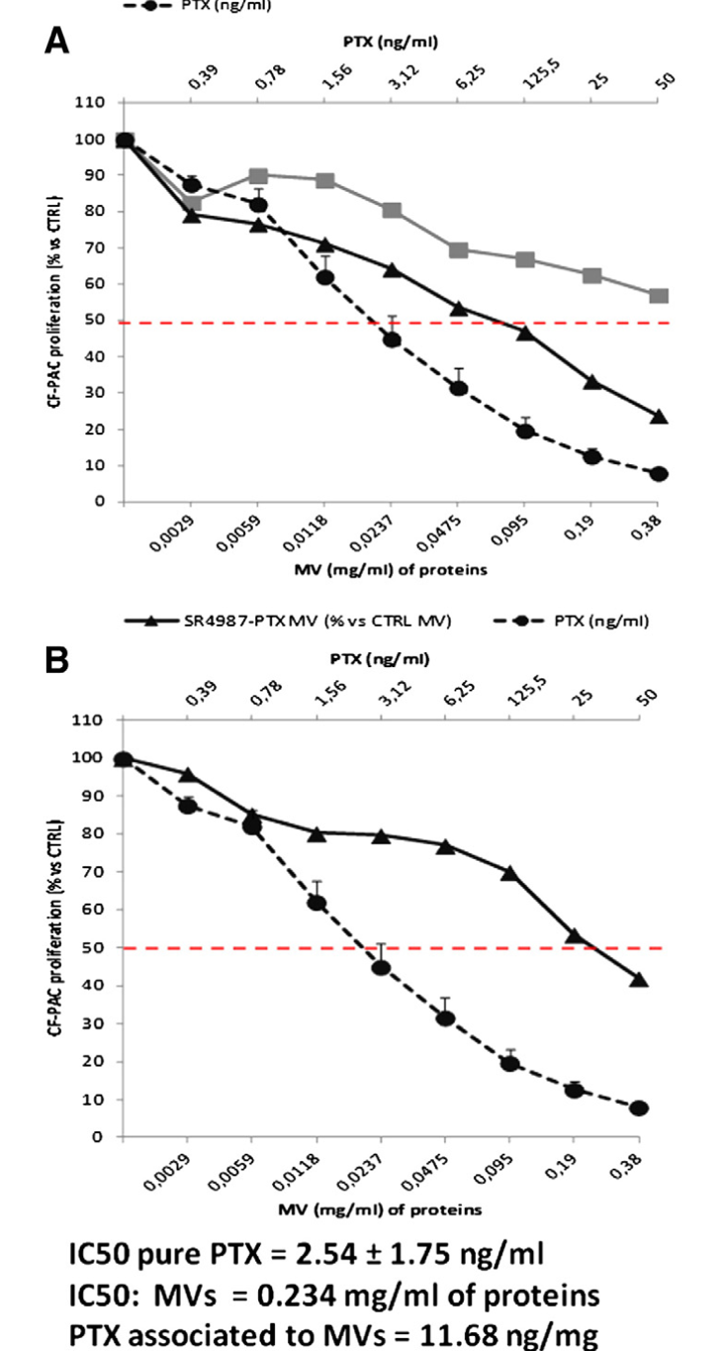

1. Elnaz Bagheri et al., Targeted doxorubicin-loaded mesenchymal stem cells-derived exosomes as a versatile platform for fighting against colorectal cancer – Life Sciences 261 2020 – Doi: 10.1016/j.lfs.2020.118369 [7]

In this research, researchers encapsulated doxorubicin (DOX), a medication used to treat various cancers, including AIDS-associated Kaposi’s Sarcoma and metastatic cancers, through electroporation method with an encapsulation efficiency of up 35%.

For guided drug delivery against MUC-1-positive cancer cells, the MUC1 aptamer (5TR1), was covalently conjugated using ED/NHS chemistry with the amine groups on the surface of MSC-derived exosomes.

Characterization of exosomes isolated from murine MSCs

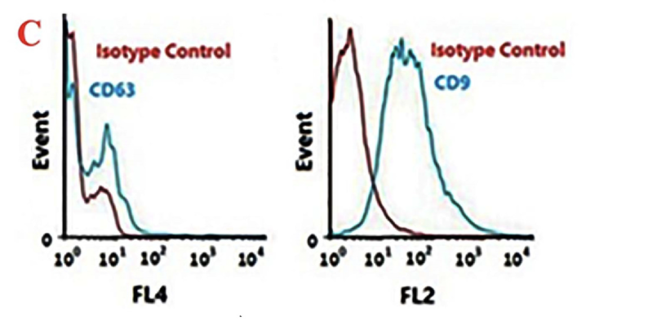

Flow cytometry analysis of CD63 and CD9 protein markers on the surface of the exosomes as positive markers.

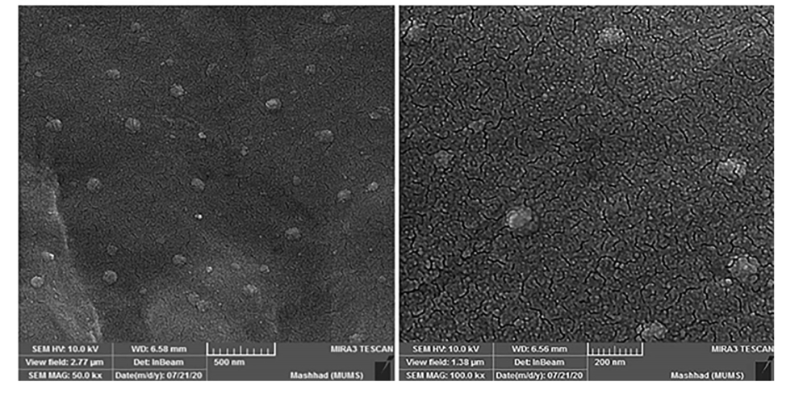

SEM images of exosome with 500 and 200 nm scale bars

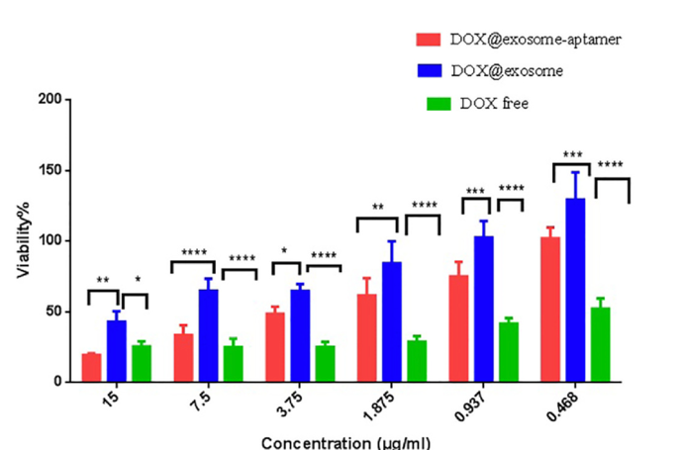

Cellular toxicity assessment of free DOC, DOX@exosome and DOX@exosome-apt

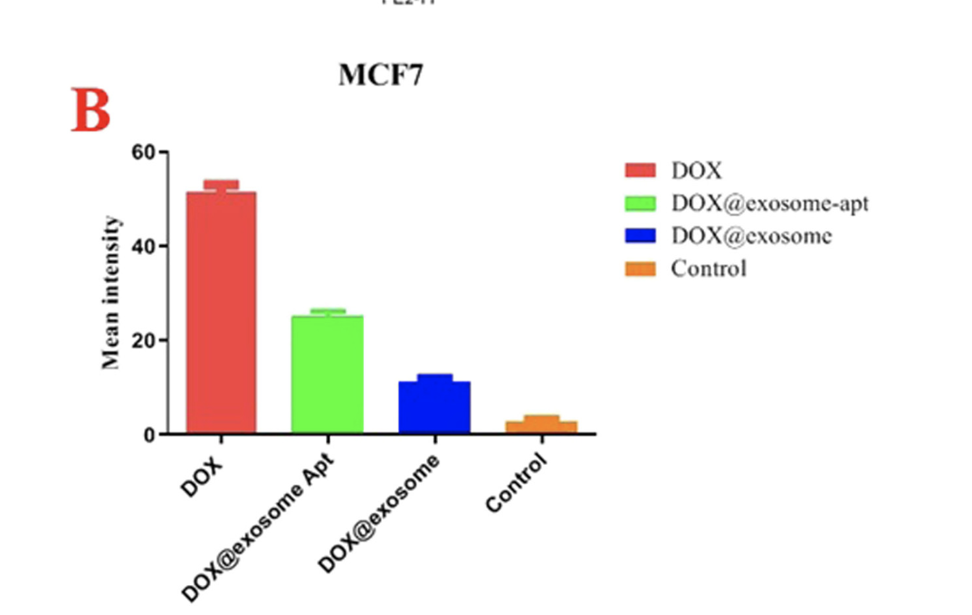

Tumor Cancer Cell MCF7 Cellular uptake with either DOX,DOX@exosome-apt, DOX@exosome and Control

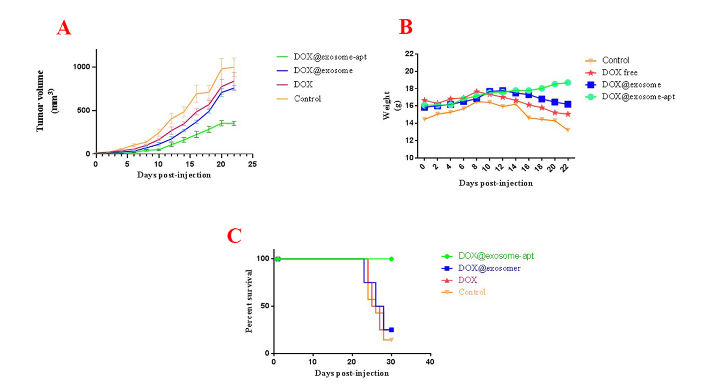

The in-vivo efficiency of the different systems

* Fluorescent images proved that DOX@exosomes-apt exhibit significantly higher DOX accumulation at tumor site.
* In comparison with free DOX at 6 h post-injection, DOX@exosomes and DOX@exosomes-apt showed significantly low DOX concentration in heart tissues. The liver accumulation, 6 h post-injection was high for all groups while DOX@exosomes-apt injected group demonstrated faster liver clearance 24 h post-injection.

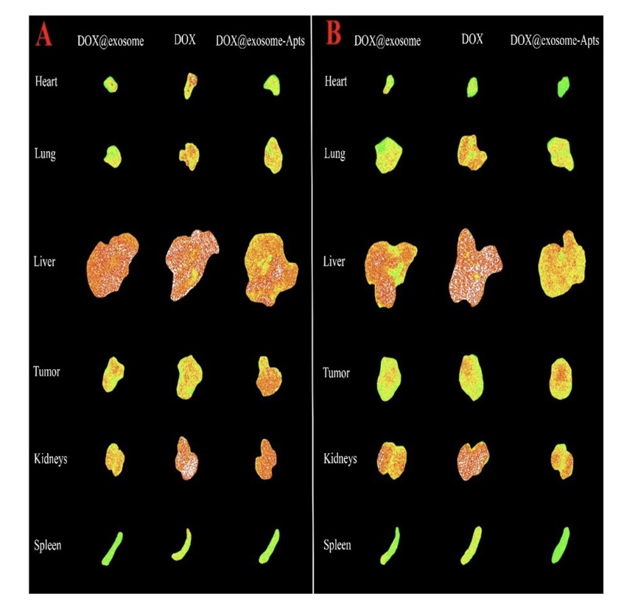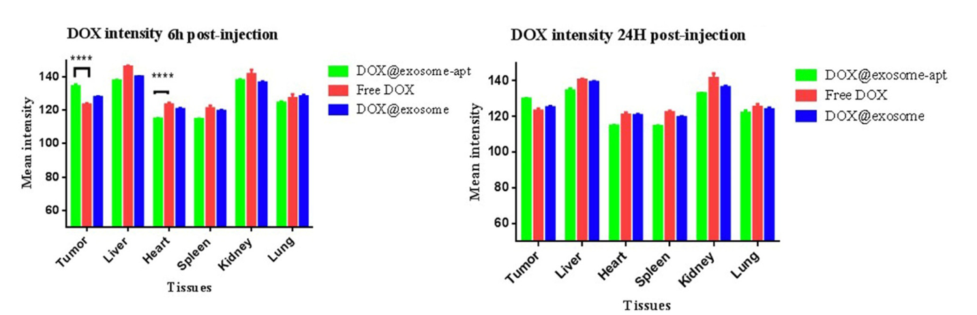

1. Pial L. Rodrigues, Minimal “self” Peptides That Inhibit Phagocytic Clearance and Enhance Delivery of Nanoparticles, Science 2013, Doi: 10.1126/science.1229568 [8]
2. To enhance the specificity of iPSC-MSC-derived exosomes for targeting tumor-associated macrophages (TAMs) and cancer cells, we must delicately balance the need for efficient TAM targeting with the imperative to evade uptake by macrophages and leukocytes in the Mononuclear Phagocyte System (MPS) organs. This optimization is critical to ensure that the engineered exosomes maintain sufficient circulation time to effectively reach and target tumors.
3. Considering the limitations associated with PEGylation, we are exploring alternative strategies such as "Self" peptide conjugation. This approach aims to modify the exosome surface with self-peptides that mimic endogenous proteins, thereby potentially reducing recognition by MPS cells while preserving exosome integrity and targeting specificity:

* **Combine CD47 expression:** with other targeting ligands specific to TAMs. By incorporating TAM-specific ligands on the exosome surface, such as antibodies against TAM markers (e.g., CD206, CD163), the exosomes can selectively target TAMs despite CD47-mediated immune evasion.
* **Optimization of CD47 Expression Levels**: Modulate the expression levels of CD47 on exosomes to balance immune evasion with TAM targeting. Fine-tuning CD47 expression can potentially optimize exosome biodistribution and maximize TAM targeting.

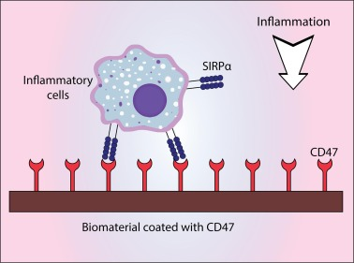

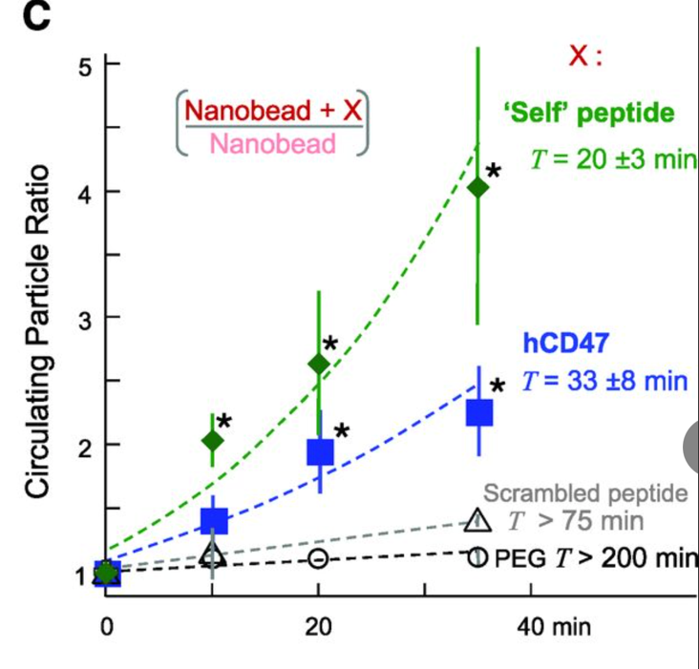

hCD47 nanobeads prolongs bloodstream circulation.

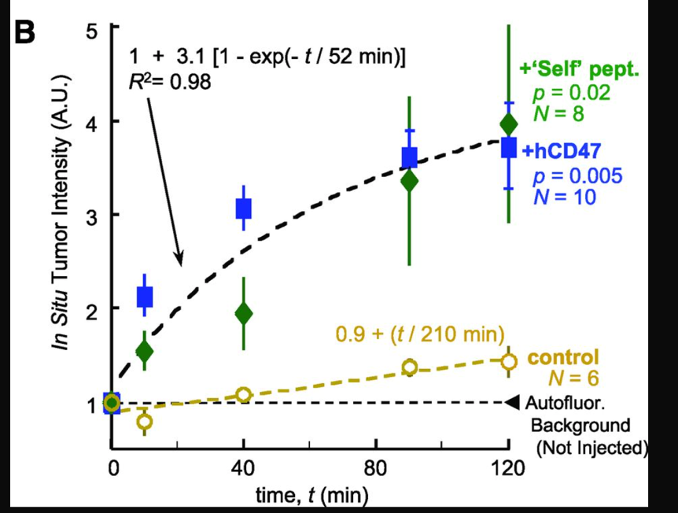

Paclitaxel, cancer drug (Tax) was loaded into Self nanobeads, as well as into beads with PEG and/or antibody against hCD47. Tax-loaded beads hCD47 or Self-peptide plus PEG and hCD47-targeting antibody shrank tumors more than beads lacking Self.

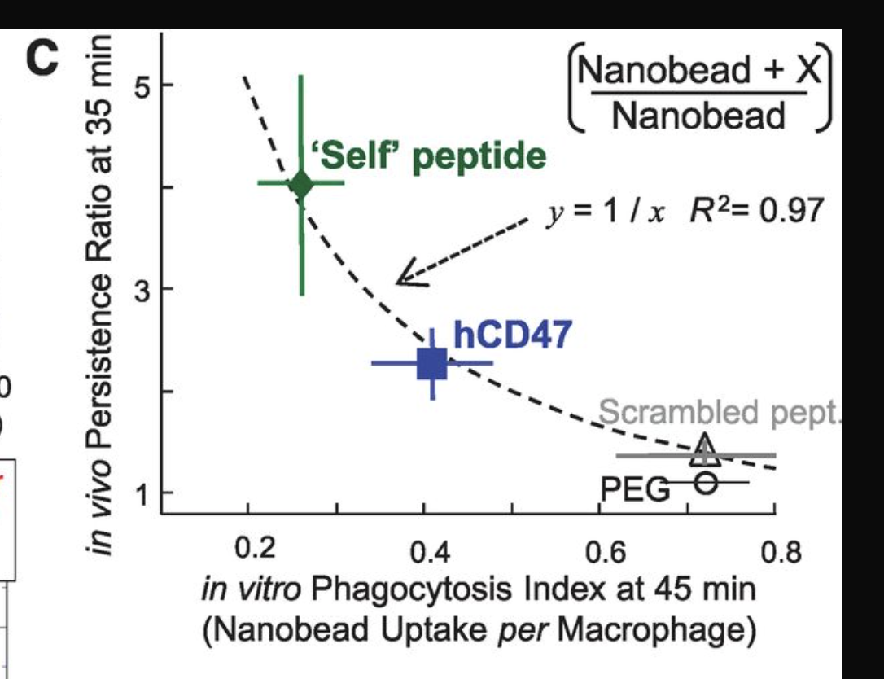

The inverse correlation between uptake by immune cells and persistence in vivo indicates a potential mechanism underlying nanoparticle clearance or elimination from the body. It suggests that nanoparticles taken up more efficiently by immune cells may be more readily cleared from circulation, while those with lower uptake may exhibit prolonged circulation times: exosomes with reduced immune cell uptake, are more likely to evade immune clearance and reach their target tissue.

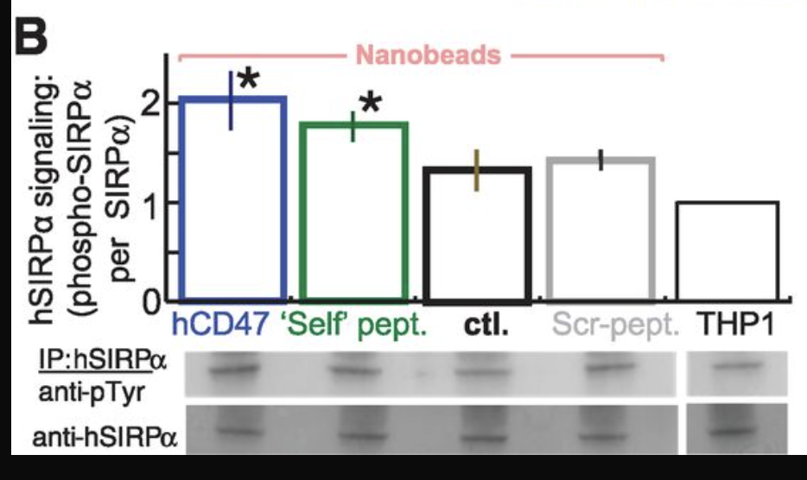

Binding of hCD47 and Self peptide increases phosphor-SIRP $α$

1. Catharina Melzer et al., Taxol-Loaded MSC-Derived Exosomes Provide a

Therapeutic Vehicle to Target Metastatic Breast Cancer and Other Carcinoma Cells

CANCERS 2019, Doi: 10.3390/cancers11060798 [9]

1. Various human cancer cell lines, including A549 lung cancer, SK-OV-3 ovarian cancer, and MDA-hyb1 breast cancer cells, were exposed to exosomes derived from human mesenchymal stroma/stem-like cells (MSCs) treated with sub-lethal doses of Taxol (Paclitaxel, a very common chemotherapy drug) for 24 hours.
2. While exosomes from untreated MSCs showed minimal impact on tumor cell growth, those derived from Taxol treated MSCs exhibited remarkable cytotoxicity, ranging from 80% to 90%. Quantitative analysis via LC-MS/MS revealed a notable 7.6-fold decrease in Taxol concentration within MSC exosomes compared to equivalent cytotoxic doses of Taxol alone, indicating a heightened tumor-targeting efficacy.
3. Subsequently, the efficacy of MSC-derived Taxol exosomes was evaluated in vivo using NODscid mice bearing highly metastatic MDA-hyb1 breast tumors. Systemic administration of MSC-derived Taxol exosomes led to a remarkable reduction of over 60% in subcutaneous primary tumors. Furthermore, metastases to distant organs such as lung, liver, spleen, and kidney were halved, mirroring the effects of Taxol, despite the exosome-bound Taxol being approximately 1000-fold less concentrated.

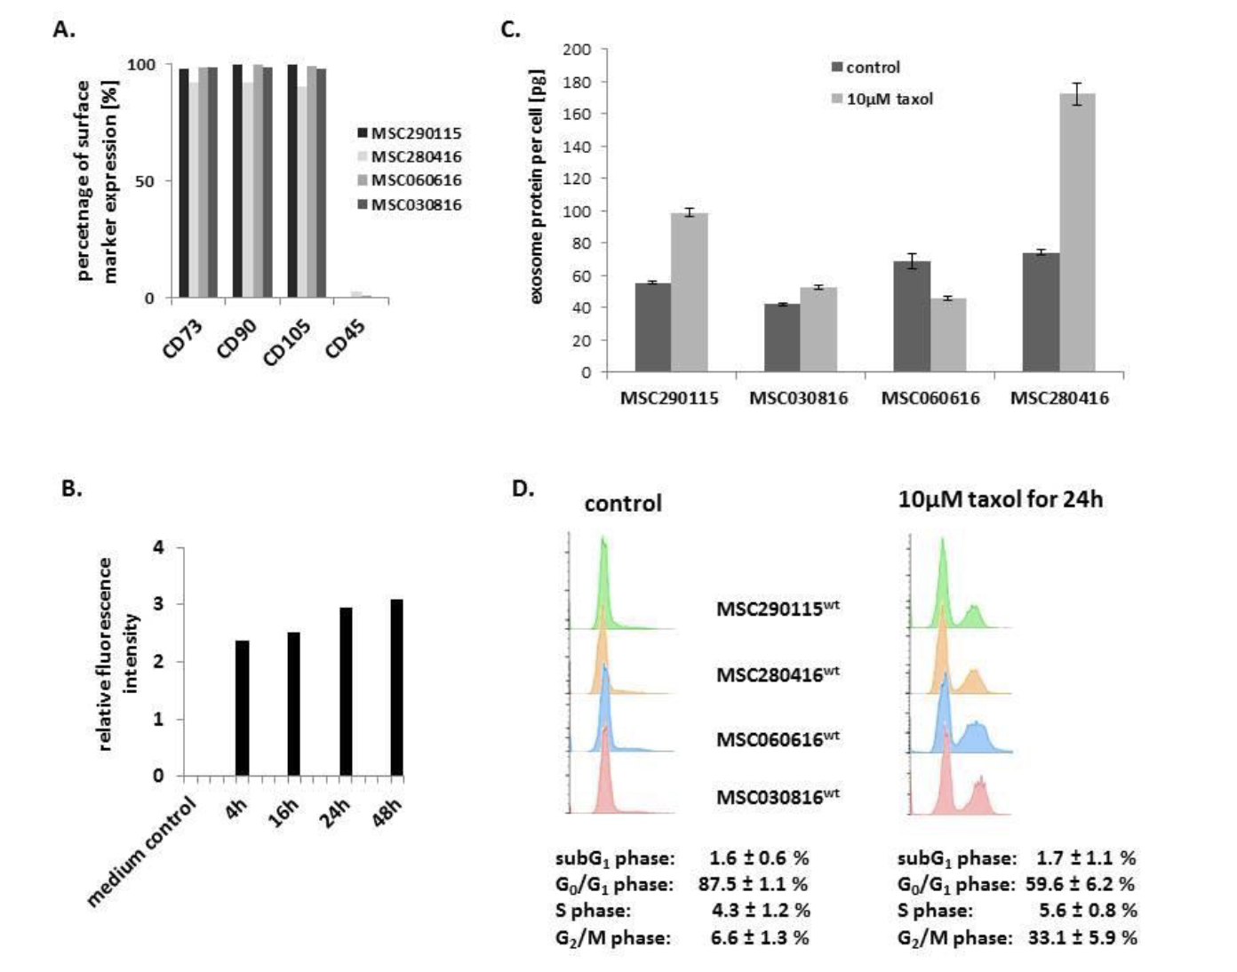

1. Characterization of the four different MSC investigated populations.
2. Kinetic of exosomes production by MSCGFP, progressive exosome release increase to reach a plateau after 24h.
3. Quantification of exosome produced per cell within a specific timeframe:

Taxol-treated of MSC exhibited an average of 134.8 ± 67.1 μg exosome protein produced by 1.68 ± 0.7 × 106 MSC, which equals 92.4 ± 58.2 pg exosome protein per Taxol-treated cell within 24 h.

1. Apoptotic/necroptotic subG1 phase cells remained at equally low levels in control (1.6% ± 0.6%) and Taxol-treated (1.7% ± 1.1%) MSC populations, confirming no detectable cytotoxic effects.

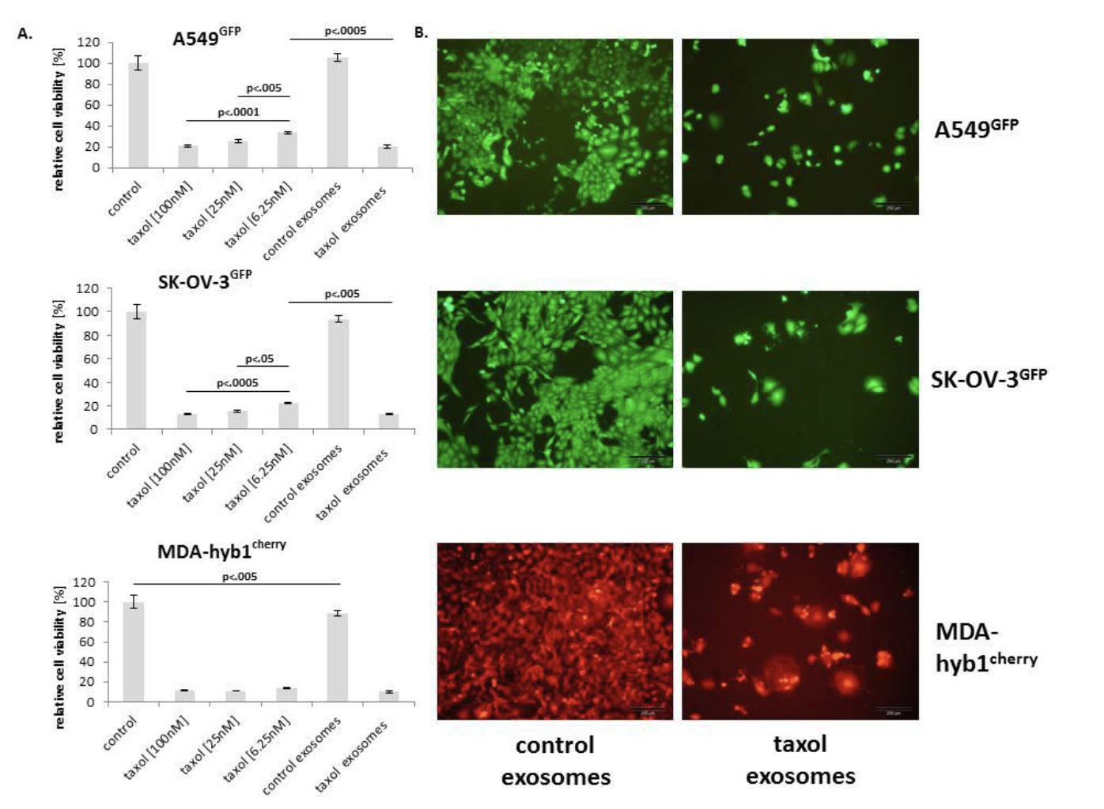

* Relative chemotherapeutic response of different human cancer cell populations, including A549GFP lung cancer (upper panel), SK-OV-3GFP ovarian cancer (middle panel), and MDA-hyb1cherry breast cancer (lower panel) cells, was tested for relative cell viability after exposure to different concentrations of Taxol (100 nM, 25 nM, and 6.25 nM) compared to the appropriate steady state cancer cell populations cultured in the highest solvent concentration of Taxol (control).
* These findings suggested that MSC-derived Taxol exosomes displayed a markedly enhanced tumor cell killing efficiency, albeit carrying 7.6-fold less Taxol.
* In the right GFP panels a significantly reduced cell number accompanied by apoptotic/necroptotic disintegration of the different cancer cell populations was observed within 72 h following treatment with MSC Taxol-primed exosomes.

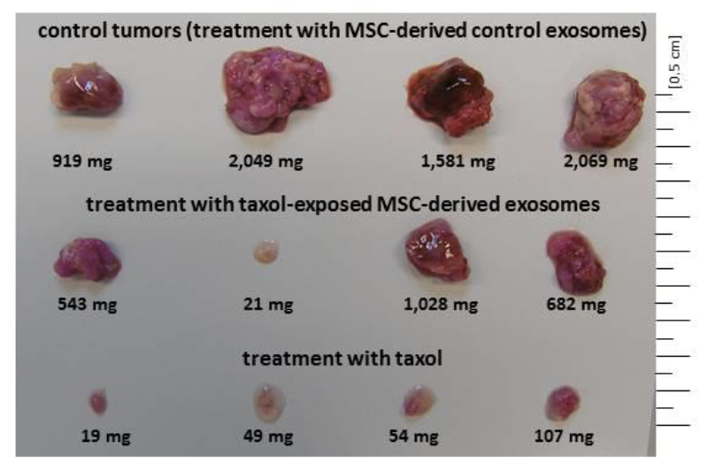

Following treatment with exosomes isolated from previously Taxol-incubated MSC, the average tumor weight was reduced by 64.2%, reaching 593 ± 394 mg (n = 4)

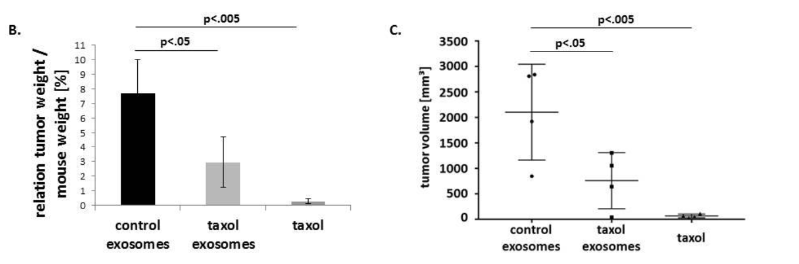

* The ratio of tumor weight to mouse weight decreased from 7.7 ± 2.3 in control tumors by 62.3% to 2.9 ± 1.7 in Taxol exosome-treated tumors and further down to 0.3 ± 0.1 in Taxol-treated tumors.
* The average control tumor volume of 2103 ± 815 mm3 decreased by 63.9% to 759 ± 477 mm3 in Taxol exosome-treated tumors and to 66 ± 32 mm3 in Taxol-treated tumors.

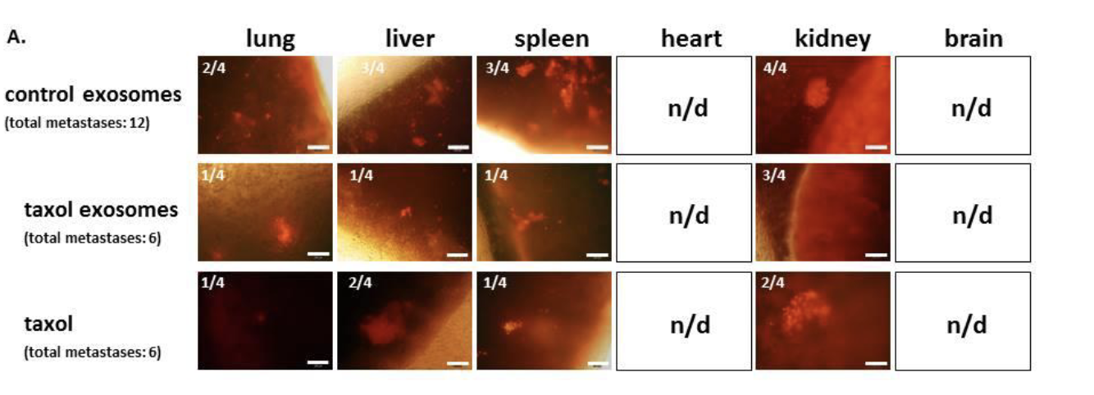

Detection and formation of distant organ metastases: a total of 12 organ metastases (lung, liver, spleen, and kidney) in control mice were reduced to six identified metastases in Taxol exosome-treated mice. The same number of six total organ metastases was detectable in mice after application with maximal doses of Taxol.

1. Jing Li et al., Aiduqing formula inhibits breast cancer metastasis by suppressing TAM/CXCL1-induced Treg differentiation and infiltration, Cell Communication and Signaling 2021, Doi: 10.1186/s12964-021-00775-2 [10]
2. Aiduqing (ADQ), is used in clinics to treat breast cancer. It has been shown to inhibit breast cancer metastasis by suppressing TAM/CXCL1-induced Treg differentiation and infiltration. It has also been shown that ADQ inhibit the proliferation, migration, autophagy cancer cells, while also inducing apoptosis.
3. Although this paper is not related directly to our proposed research, it provides a description of experiments to measure the increase infiltration of tumor-infiltrating lymphocytes (TILs) and cytotoxic CD8+ T cells, and the decrease of infiltration of Tregs, naïve CD4 + T cells, and TAMs.

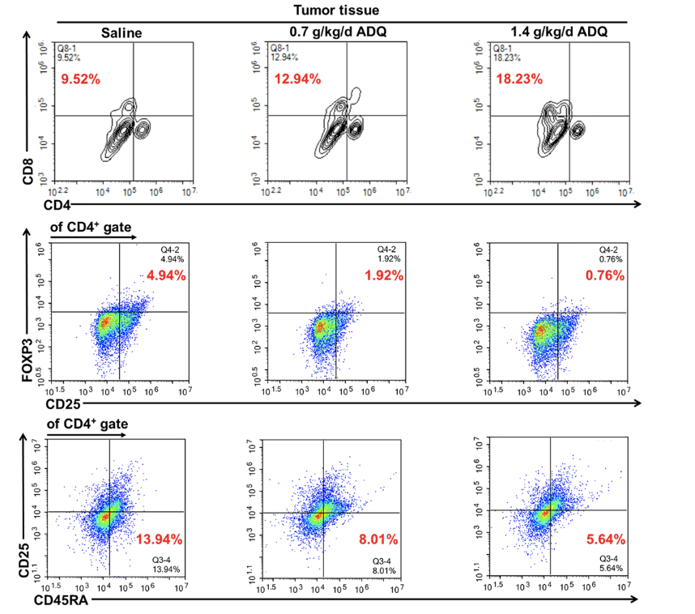 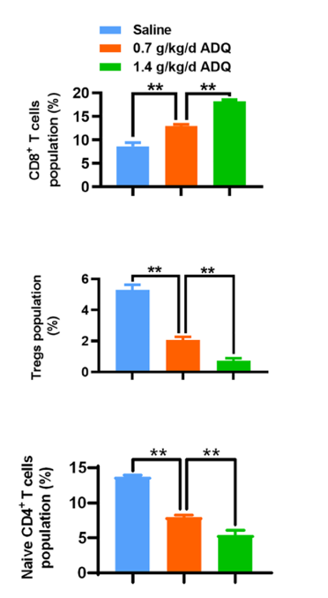

The infiltration levels of cytotoxic CD8+ T cells, CD4+/CD25+/FOXP3+ Tregs, and CD4+/ CD25−/CD45RA+ naive CD4+ T cells within the TME were quantified by flow cytometry.

Reference:

[1] C. Almeria, S. Kreß, V. Weber, D. Egger, and C. Kasper, “Heterogeneity of mesenchymal stem cell-derived extracellular vesicles is highly impacted by the tissue/cell source and culture conditions,” *Cell Biosci.*, vol. 12, no. 1, p. 51, 2022, doi: 10.1186/s13578-022-00786-7

[2] V. Dupuis and E. Oltra, “Methods to produce induced pluripotent stem cell-derived mesenchymal stem cells: Mesenchymal stem cells from induced pluripotent stem cells,” *World J. Stem Cells*, vol. 13, no. 8, pp. 1094–1111, 2021, doi: 10.4252/wjsc.v13.i8.1094

[3] Z. Weng *et al.*, “Therapeutic roles of mesenchymal stem cell-derived extracellular vesicles in cancer,” *J. Hematol. Oncol.*, vol. 14, no. 1, p. 136, 2021, doi: 10.1186/s13045-021-01141-y

[4] J. Chen *et al.*, “Review on Strategies and Technologies for Exosome Isolation and Purification,” *Front. Bioeng. Biotechnol.*, vol. 9, p. 811971, 2022, doi: 10.3389/fbioe.2021.811971

[5] C. Ulpiano, C. L. da Silva, and G. A. Monteiro, “Bioengineered Mesenchymal-Stromal-Cell-Derived Extracellular Vesicles as an Improved Drug Delivery System: Methods and Applications,” *Biomedicines*, vol. 11, no. 4, p. 1231, 2023, doi: 10.3390/biomedicines11041231

[6] L. Pascucci *et al.*, “Paclitaxel is incorporated by mesenchymal stromal cells and released in exosomes that inhibit in vitro tumor growth: A new approach for drug delivery,” *J. Control. Release*, vol. 192, pp. 262–270, 2014, doi: 10.1016/j.jconrel.2014.07.042

[7] E. Bagheri, K. Abnous, S. A. Farzad, S. M. Taghdisi, M. Ramezani, and M. Alibolandi, “Targeted doxorubicin-loaded mesenchymal stem cells-derived exosomes as a versatile platform for fighting against colorectal cancer,” *Life Sci.*, vol. 261, p. 118369, 2020, doi: 10.1016/j.lfs.2020.118369

[8] P. L. Rodriguez, T. Harada, D. A. Christian, D. A. Pantano, R. K. Tsai, and D. E. Discher, “Minimal ‘Self’ Peptides That Inhibit Phagocytic Clearance and Enhance Delivery of Nanoparticles,” *Science*, vol. 339, no. 6122, pp. 971–975, 2013, doi: 10.1126/science.1229568

[9] C. Melzer, V. Rehn, Y. Yang, H. Bähre, J. von der Ohe, and R. Hass, “Taxol-Loaded MSC-Derived Exosomes Provide a Therapeutic Vehicle to Target Metastatic Breast Cancer and Other Carcinoma Cells,” *Cancers*, vol. 11, no. 6, p. 798, 2019, doi: 10.3390/cancers11060798

[10] J. Li *et al.*, “Aiduqing formula inhibits breast cancer metastasis by suppressing TAM/CXCL1-induced Treg differentiation and infiltration,” *Cell Commun. Signal.*, vol. 19, no. 1, p. 89, 2021, doi: 10.1186/s12964-021-00775-2